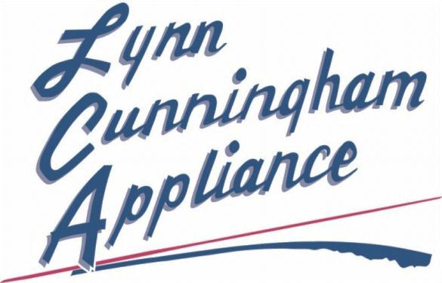

3991 South Valley Drive

Longmont, CO 80504

I-25 & Hwy 66

Sales

Service

Parts

“It’s not just business… It’s personal!”

(303) 651-3799 or (970) 535-0980

Mention this internet ad to receive 10% off any appliance